ព្រះរាជាណាចក្រកម្ពុជា

ជាតិ​ សាសនា ព្រះមហាក្សត្រ

Institute of technology of Cambodia

Department of Information and communication Engineering



The lesson taking about using recursive function in c++

TP13 Recursive function

TP: Algorithm and Programming ll

Lecturer: BOU CHANNA

Student: VEN THON

ID: e20191250

Group: I3-GIC-C

Year: 2022-2023

Contents

Problem1: 3

Problem2: 5

Problem3: 7

Problem4: 8

Problem5: 9

# 

# Problem1:

A C++program that can perform various mathematic operations below.Solve each operation using recursive operation.a

.A power function to calculate mn.It is mmultiply mfor n times(m*m*...*m)int power(int m, int n)

b.A function to calculate sum of square of first n integer 12+22+...+n2.int sumSquare(int n)

c.Sumthe digits of a number.int sumDigit(int n)

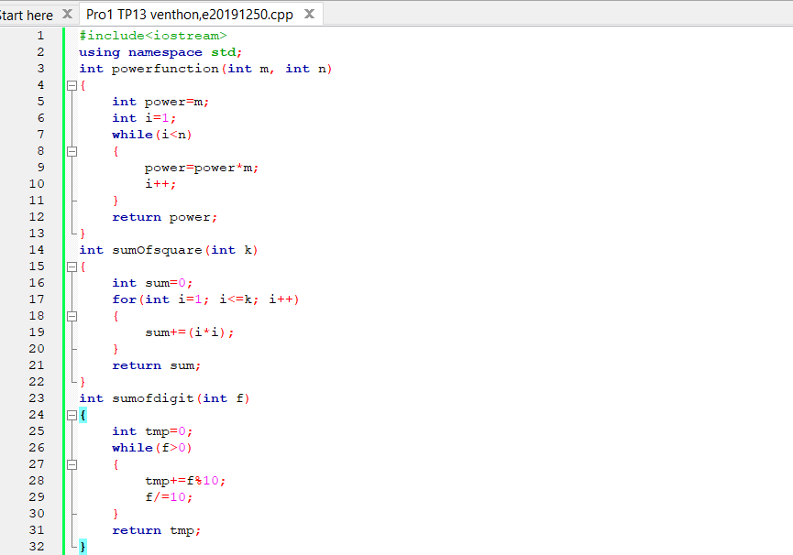

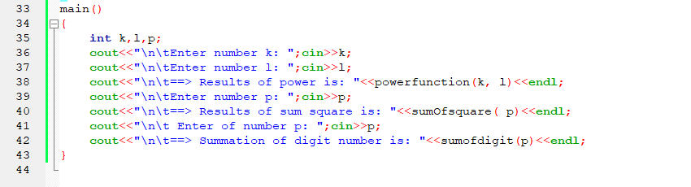

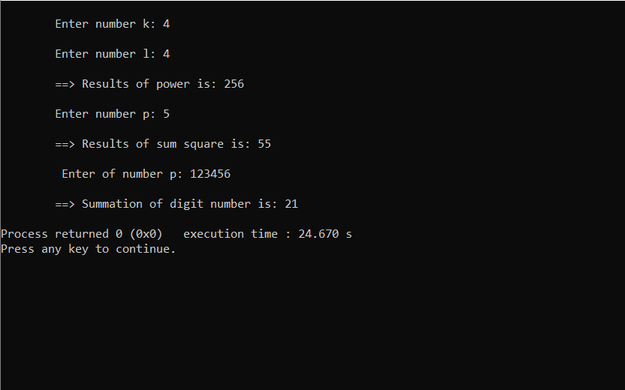

# 

# Problem2:

A C++Program that can do someoperationsbelow. (makea menu for your program so that users can test any functions. Run it as infinite loop). Solve each operation using recursive operation.

a.Afunctionto display n star (*)void displayStar(int n)

b.Display numbers from n to 1void displayNumbers(int n)

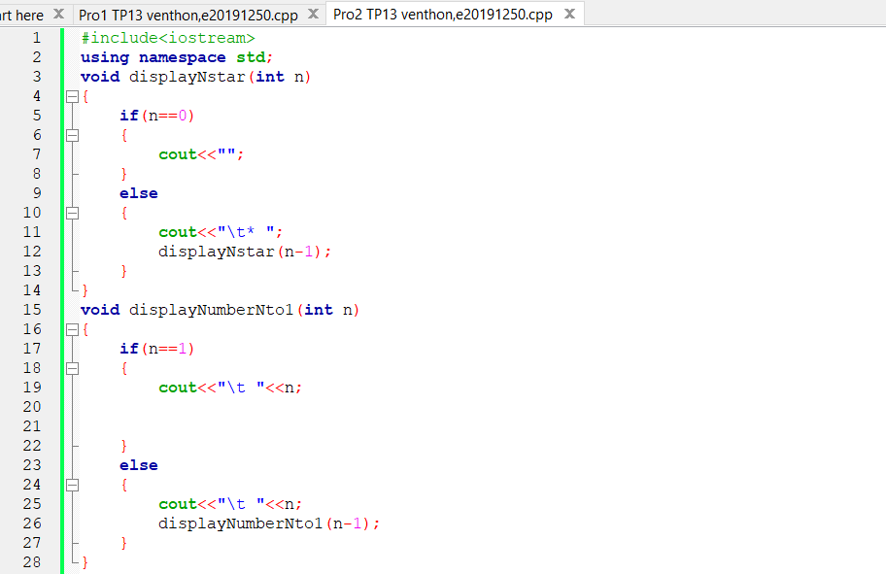

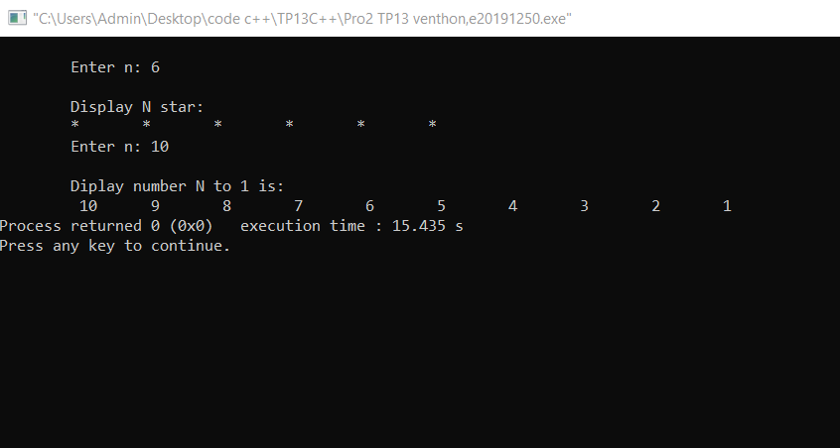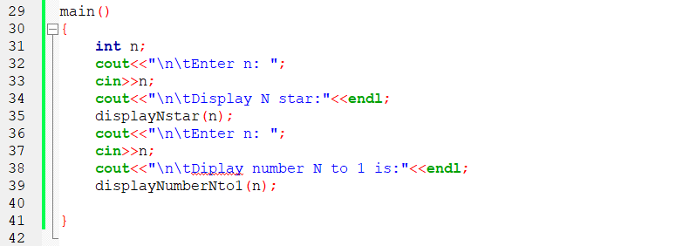

# 

# Problem3:

Write arecursivefunction to find multiplication of all elementsin an array,wherethearray and itssize arepassed as parameters of function. int multiplyArrayElement(int a[], int size)

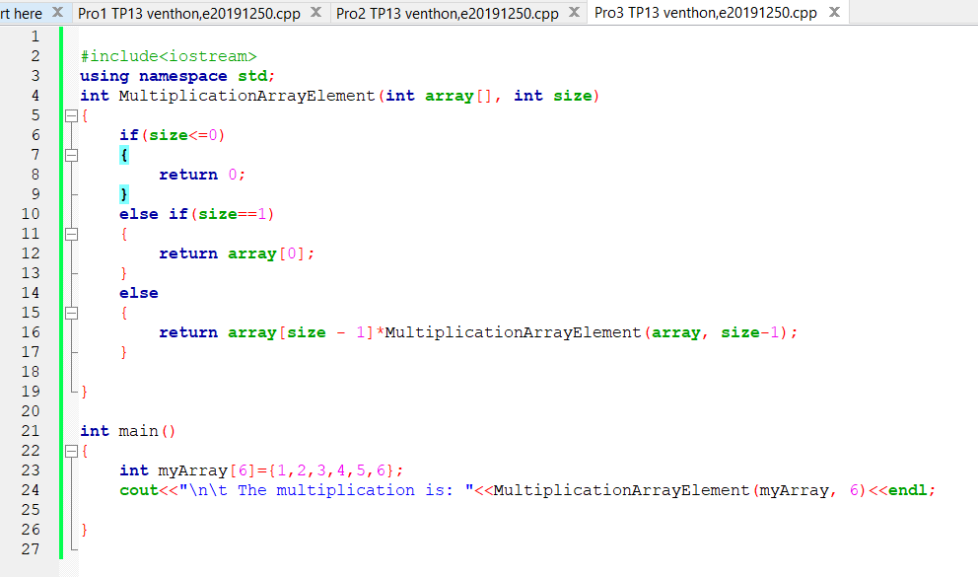

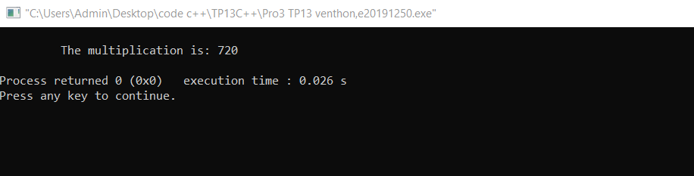

# Problem4:

Write a recursive function that finds and returns the minimum element in an array, where the array and its size are given as parameters

.int findMin(int a[], int n)

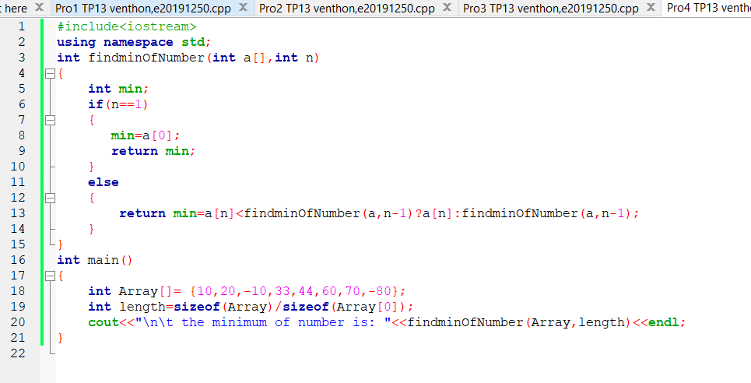

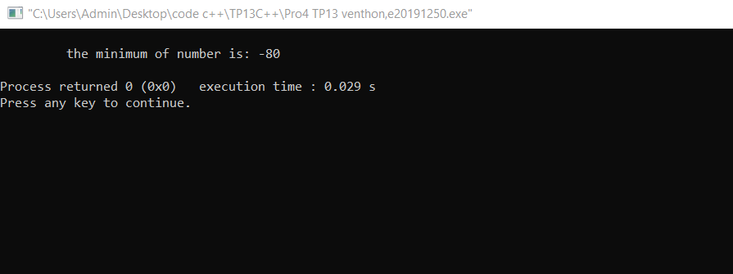

# Problem5:

Write a recursive function that computes and returns the sum of all elements in an array, where the array and its size are given as parameters.int findsum(int a[], int n)

